1. **Project Title:** MediScan: AI-Powered Medical Image Analysis for Disease Diagnosis
2. **Project Statement and Outcomes:**
3. Develop an advanced AI-powered system for medical image analysis to enable accurate Eye disease detection, early diagnosis, automated image interpretation, quantitative analysis, clinical decision support, and scalable deployment across diverse healthcare settings, fostering collaboration, regulatory compliance, and knowledge sharing for improved patient care.
4. Implementation of the MediScan system results in enhanced Eye disease detection and diagnosis through AI-powered medical image analysis, improving patient outcomes and facilitating more efficient clinical workflows.
5. **Modules to be Implemented:**

* Project Setup and Data Collection
* Preprocessing and Image Segmentation
* Feature Extraction and Machine Learning Model Training
* Integration and Validation
* Review, Bug Fixes, Documentation

1. **Week-wise module implementation and high-level requirements:**

Week 1-2: Project Setup and Data Collection

* Set up the development environment, version control system, and project management tools.
* Define project objectives, requirements, and timeline.
* Allocate roles and responsibilities among team members.
* Identify relevant features to train the model & collect the dataset.
* Implement functionality to store acquired images in a centralized database for further processing.

Week 3-4: Preprocessing and Image Segmentation

* Implement preprocessing techniques to enhance the quality of acquired eye images, including noise reduction, image enhancement, and normalization.
* Validate preprocessing methods and optimize parameters for different imaging modalities.
* Develop algorithms to segment Eye images and isolate regions of interest, such as organs, tissues, or lesions, for further analysis.
* Test segmentation algorithms on diverse datasets and refine them to improve accuracy and robustness.

Week 5-6: Feature Extraction and Machine Learning Model Training

* Implement feature extraction techniques to extract relevant features from segmented regions of images.
* Explore various feature representation methods, such as texture analysis, shape descriptors, and intensity histograms.
* Train machine learning models, such as convolutional neural networks (CNNs), using annotated medical image datasets to learn disease patterns and features.
* Validate model performance using cross-validation techniques and fine-tune hyperparameters for optimal results.

Week 7-8:Review, Bug Fixes, Documentation

* Conduct a thorough review of the entire system, including functionality, security, and user interface.
* Address any identified bugs or issues and perform necessary fixes.
* Prepare comprehensive documentation covering system architecture, user guides, and technical specifications.

1. **Diagrams:**

* Flowchart

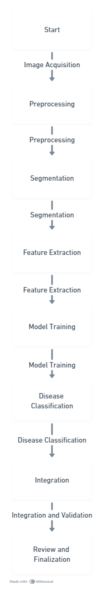

1. **Sample Input:**

The data set contains the images that help the ML model to predict.When we give in the image that predicts the disease.

|  |  |
| --- | --- |
|  |  |

**7.Sample Output:**

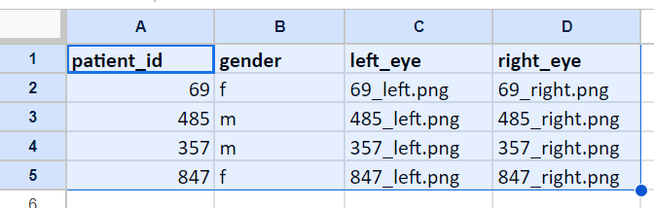

1. **Sample Output:**

